Samantha Naini
Info 233 – Programming in Visual Basic
Professor Klein
2/2/2012

HW#2: Exercise 2.3, numbers 33, 34, 35, 36, 37, 38

33)
Public Class frmAlign

Private Sub frmAlign_Load(ByVal sender As System.Object, ByVal e As System.EventArgs) Handles MyBase.Load
End Sub

Private Sub btnLeft_Click(ByVal sender As System.Object, ByVal e As System.EventArgs) Handles btnLeft.Click
txtBox.Text = "Left Justify"
txtBox.TextAlign = HorizontalAlignment.Left
End Sub

Private Sub btnCenter_Click(ByVal sender As System.Object, ByVal e As System.EventArgs) Handles btnCenter.Click
txtBox.Text = "Center"
txtBox.TextAlign = HorizontalAlignment.Center
End Sub

Private Sub btnRight_Click(ByVal sender As System.Object, ByVal e As System.EventArgs) Handles btnRight.Click
txtBox.Text = "Right Justify"
txtBox.TextAlign = HorizontalAlignment.Right
End Sub

End Class

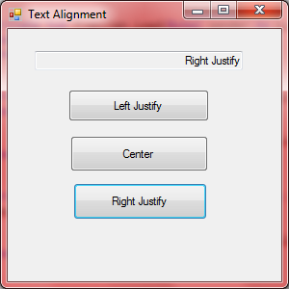

34)
Public Class frmFace

Private Sub Button2_Click(ByVal sender As System.Object, ByVal e As System.EventArgs) Handles btnFrown.Click
lblFace.Text = "L"
End Sub

Private Sub lblFace_Click(ByVal sender As System.Object, ByVal e As System.EventArgs) Handles lblFace.Click

End Sub

Private Sub btnSmile_Click(ByVal sender As System.Object, ByVal e As System.EventArgs) Handles btnSmile.Click
lblFace.Text = "J"
End Sub
End Class
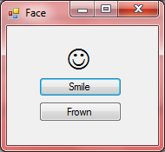

35)

Public Class frmColors

Private Sub Button3_Click(ByVal sender As System.Object, ByVal e As System.EventArgs) Handles btnWhite.Click
txtBox.ForeColor = Color.White
End Sub

Private Sub Button4_Click(ByVal sender As System.Object, ByVal e As System.EventArgs) Handles btnYellow.Click
txtBox.ForeColor = Color.Yellow
End Sub

Private Sub Button2_Click(ByVal sender As System.Object, ByVal e As System.EventArgs) Handles btnBlue.Click
txtBox.BackColor = Color.Blue
End Sub

Private Sub btnRed_Click(ByVal sender As System.Object, ByVal e As System.EventArgs) Handles btnRed.Click
txtBox.BackColor = Color.Red
End Sub
End Class

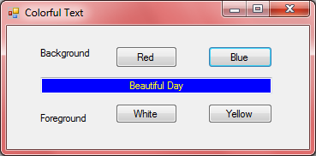

36) (***I had trouble with this problem***)

Public Class frm123

Private Sub txtOne_Enter(ByVal sender As System.Object, ByVal e As System.EventArgs) Handles txtOne.Enter
txtOne.ForeColor = Color.Red
End Sub

Private Sub txtOne_Leave(ByVal sender As System.Object, ByVal e As System.EventArgs) Handles txtOne.Leave
txtOne.ForeColor = Color.Black
End Sub

Private Sub txtTwo_Enter(ByVal sender As System.Object, ByVal e As System.EventArgs) Handles txtTwo.Enter
txtTwo.ForeColor = Color.Red
End Sub

Private Sub txtTwo_Leave(ByVal sender As System.Object, ByVal e As System.EventArgs) Handles txtTwo.Leave
txtTwo.ForeColor = Color.Black
End Sub

Private Sub txtThree_Enter(ByVal sender As System.Object, ByVal e As System.EventArgs) Handles txtThree.Enter
txtThree.ForeColor = Color.Red
End Sub

Private Sub txtThree_Leave(ByVal sender As System.Object, ByVal e As System.EventArgs) Handles txtThree.Leave
txtThree.ForeColor = Color.Black
End Sub

Private Sub btnLeft_Click(ByVal sender As System.Object, ByVal e As System.EventArgs) Handles btnLeft.Click, txtOne.Click
txtOne.Text = "One"
txtOne.TextAlign = HorizontalAlignment.Left
End Sub

Private Sub btnLeft_Click(ByVal sender As System.Object, ByVal e As System.EventArgs) Handles btnLeft.Click, txtTwo.Click
txtTwo.Text = "Two"
txtOne.TextAlign = HorizontalAlignment.Left
End Sub

Private Sub btnLeft_Click(ByVal sender As System.Object, ByVal e As System.EventArgs) Handles btnLeft.Click, txtThree.Click
txtTwo.Text = "Three"
txtOne.TextAlign = HorizontalAlignment.Left
End Sub

Private Sub btnRight_Click(ByVal sender As System.Object, ByVal e As System.EventArgs) Handles btnRight.Click, txtOne.Click
txtOne.Text = "One"
txtOne.TextAlign = HorizontalAlignment.Right
End Sub

Private Sub btnRight_Click(ByVal sender As System.Object, ByVal e As System.EventArgs) Handles btnRight.Click, txtTwo.Click
txtTwo.Text = "Two"
txtTwo.TextAlign = HorizontalAlignment.Right
End Sub

Private Sub btnRight_Click(ByVal sender As System.Object, ByVal e As System.EventArgs) Handles btnRight.Click, txtThree.Click
txtThree.Text = "Three"
txtThree.TextAlign = HorizontalAlignment.Right
End Sub

End Class
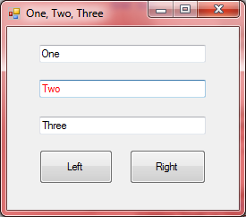

37)

Public Class frmQuote

Private Sub txtLife_Enter(ByVal sender As System.Object, ByVal e As System.EventArgs) Handles txtLife.Enter
txtQuote.Text = "I like life, it's something to do."
End Sub

Private Sub txtFuture_Enter(ByVal sender As System.Object, ByVal e As System.EventArgs) Handles txtFuture.Enter
txtQuote.Text = "The future isn't what it used to be."
End Sub

Private Sub txtTruth_Enter(ByVal sender As System.Object, ByVal e As System.EventArgs) Handles txtTruth.Enter
txtQuote.Text = "Tell the truth and run."
End Sub

End Class
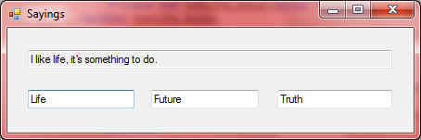

38)

Public Class frmTextBox

Private Sub btnDisable_Click(ByVal sender As System.Object, ByVal e As System.EventArgs) Handles btnDisable.Click
txtBox.Enabled = False
txtBox.ReadOnly = True
End Sub

Private Sub btnEnable_Click(ByVal sender As System.Object, ByVal e As System.EventArgs) Handles btnEnable.Click
txtBox.Enabled = True
txtBox.ReadOnly = False
End Sub

End Class

